**Combining Time Series Models to compute closing stock price**

Table of Contents

Contents

**Understanding the Data** 5

1.1 Analysis of Data using Correlation coefficient and Distance Metric 6

1.2 Distance metric to infer relationship between companies 8

1.3 BSE Banking Index 8

1.4 BSE AUTO Index 10

**Principal Component Analysis and Clustering** 12

2.1 Hierarchical Clustering 15

2.2 Clustering Using Minimum Spanning Tree 19

**Time Series Analysis of Bankex and Auto Index** 21

3.1 Autoregressive Moving Average (ARMA) 21

3.2 Autoregressive Integrated Moving Average (ARIMA) 22

3.3 BSE Bankex 23

3.3.1 Results for Bankex 27

3.3.2 BSE Auto Index 30

3.3.3 Results for BSE Auto Index 41

**Combing the Time Series Models** 53

**Abstract**

ARIMA models have been used for a plethora of time series analysis tasks. We typically try to fit an ARIMA model to predict the values of a single decision variable (like house prices, stock market values etc.). The research involves attempting to combine multiple ARIMA models into a single model, which can be used to predict the closing price of banks in BSE Sensex and also for companies listed in BSE Auto Index. Before actually delving into fitting ARIMA or ARMA models to the data, it is essential to analyse the data in hand. The data has been collected from the official BSE Sensex website and consists of the daily closing stock prices starting from January 1 2022 to November 30 2023. Initial stages of the work involved finding the correlation between banks in order to find which banks have a strong or weak relationship. Since Pearson’s Correlation coefficient only measures linear relationships, it is not the most accurate metric in our case, since stock data is highly non-linear and follows an irregular trend. Instead we go for a distance metric (1-r^2). Based on the values obtained we are able to identify strongly associated and weakly associated banks. Similar analysis has been done for companies in the BSE Auto Index. The next step involved reducing the dimensions of the data, since it is easier to process data of lower dimensions. Principal component analysis was performed and the data of 10 dimensions was reduced to 4. With the reduced data we now perform clustering using a dendrogram and also a spanning tree. The results of the clustering process are explained in subsequent sections of the paper. Once we obtain the clusters, we attempt to find the best ARIMA model for each cluster and aim to combine the models into a single model that can be used to predict the closing stock price for Dec 2023 for each bank. Similar work has been done for the BSE Auto Index.

**Introduction**

The behaviour of the stock market has always piqued the interest of people, given its highly volatile and unpredictable nature. Being able to predict the trend of the stock market serves as an interesting task, since the stock market is highly influenced by a multitude of economic and non-economic factors. Some of the key factors include the GDP growth, employment rates, consumer spending. Technological advancements can have a massive impact on the industry leading to a shift in the market dynamics. Quite surprisingly, natural disasters such as earthquakes, hurricanes too can disrupt supply chains thereby impacting the stock prices.

In this research paper, we aim to apply the techniques of machine learning and time series analysis to develop a single model which can be used to predict the closing stock prices of BSE Banking Index and BSE Auto Index. Leaving the uncontrollable elements to the hands of nature, what we have in hand is rich data of stock prices and look to utilize them in an efficient manner to predict future stock prices. We work on closing stock price data collected from January 1 2022 to November 30 2023. The task in hand is to be able to accurately predict the closing stock price of all the Banks in the BSE Banking Index and for all the companies in the BSE Auto index. The subsequent topics of the paper describe the methods adopted in order to achieve the same.

# **Understanding the Data**

Data has been collected from the official website of the Bombay Stock Exchange. We are primarily interested in predicting the closing stock price of banks in BSE Banking Index and the companies in the BSE Auto Index. Given below is a snippet of the data collected.

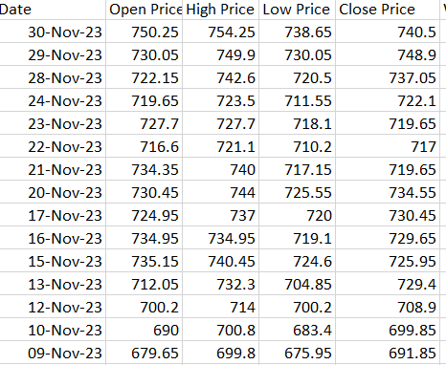

Fig 1.1 Snippet of Stock data collected from BSE Website

The data can be downloaded as a CSV file and is neatly structured, thus making the task of analysis relatively easier. We are only interested in the Close price column, and these values will be used for further analysis as described in this paper.

## 1.1 Analysis of Data using Correlation coefficient and Distance Metric

We combine the closing stock prices into a single data-frame and find the correlation coefficient in order to understand the strength of association between them. The correlation coefficient provides a numerical measure of the degree of association between the entities. It also provides the direction of relationship between the variables. A high positive value of correlation coefficient indicates both the entities have a strong relationship in the same direction, while a high negative value indicates that the entities move in the opposite direction. The correlation values obtained are visualized as a heatmap as shown in Figures 1.2 and 1.3

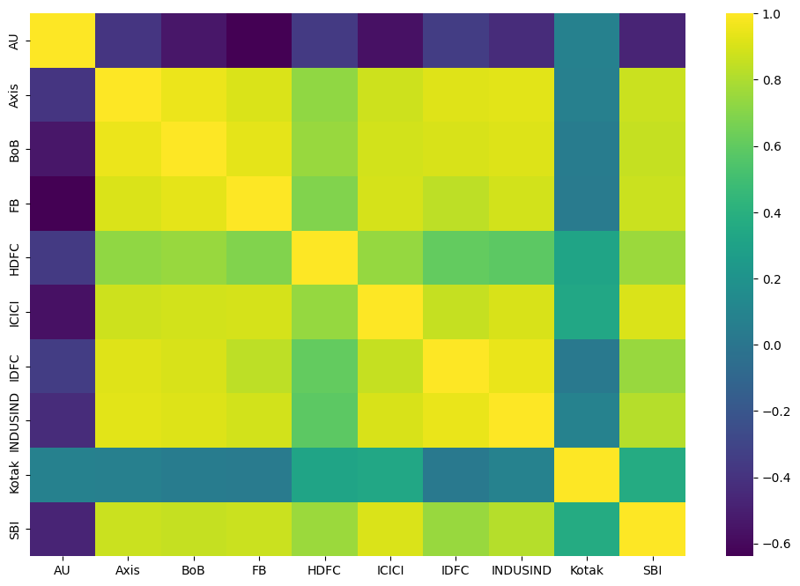

Fig 1.2 Correlation heatmap for banks in BSE Bankex

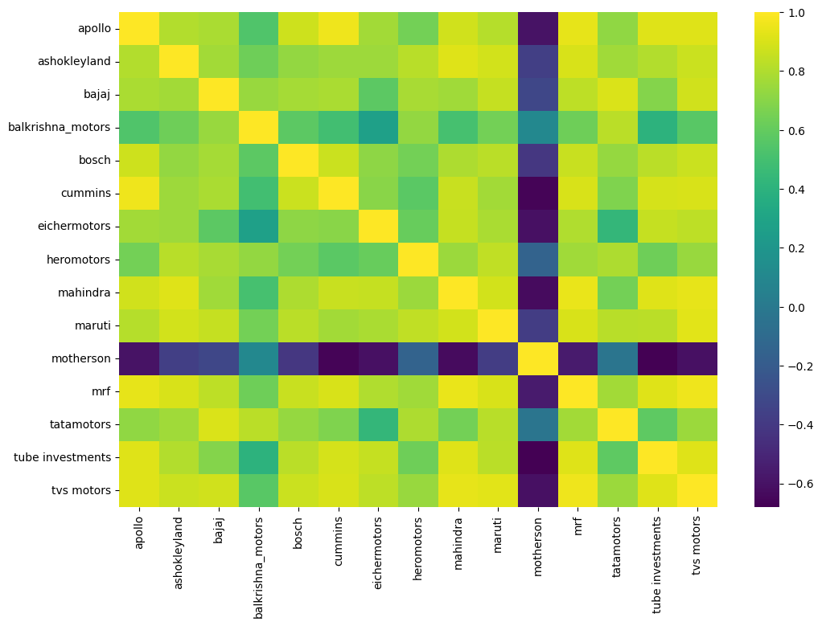

Fig 1.3 Correlation Heatmap for BSE Auto Index

From **Fig 1.2** it is evident that Axis bank (Axis) and Bank of Baroda (BoB) have a high positive correlation of 0.95, whereas Axis and AU have a correlation coefficient of -0.38. Similarly, the relationships between the other banks can be inferred.

From **Fig 1.3**. we can infer that TVS and MRF have a strong positive relationship as indicated by the correlation value of 0.95, while Apollo and Motherson have a correlation value of -0.6 which indicates that the two companies are not similar to each other. Similarly, the relationships between the other companies can be inferred.

## 1.2 Distance metric to infer relationship between companies

The distance metric 1−*ρ*2 (where *ρ* is the correlation coefficient) is another way to quantify the relationship between variables. It is inversely related to correlation coefficient (as *ρ increases the distance metric decreases and vice versa).* The distance metric is intuitive and easier to interpret. A value closer to 0 indicates that the entities are extremely similar in their behaviour whereas a higher value of the metric indicates stronger levels of dissimilarity. The distance metric is also robust to non linear relationships, thus making it a better metric for comparison than the correlation coefficient. While the results obtained from the correlation coefficient and distance metric are largely same, the distance metric is easier to interpret.

The end results of the analysis are present below.

## 1.3 BSE Banking Index

|  |  |  |
| --- | --- | --- |
| Distance metric value (d) | Type of relationship | Banks |
| 0.75<=d<=1 | Weak | * AU and Axis * AU and HDFC * AU and IDFC * AU and INDUSIND * AU and Kotak * AU and SBI * Axis and Kotak * BoB and Kotak * FB and Kotak * ICICI and Kotak * INDUSIND and Kotak * SBI and Kotak |
| 0.36<=d<0.75 | moderate | * AU and BoB * AU and FB * AU and ICICI * Axis and HDFC * BoB and HDFC * FB and HDFC * HDFC and ICICI * HDFC and IDFC * HDFC and INDUSIND * HDFC and SBI * IDFC and SBI |
| 0<=d<0.36 | strong | * Axis and BoB * Axis and FB * Axis and ICICI * Axis and IDFC * Axis and INDUSIND * Axis and SBI * BoB and FB * BoB and ICICI * BoB and IDFC * BoB and INDUSIND * BoB and SBI * FB and ICICI * FB and IDFC * ICICI and IDFC * ICICI and INDUSIND * ICICI and SBI * IDFC and INDUSIND * INDUSIND and SBI |

## 1.4 BSE AUTO Index

|  |  |  |
| --- | --- | --- |
| Distance metric value (d) | Type of relationship | Companies |
| 0.75<=d<=1 | Weak | * Ashok Leyland and Motherson * Bajaj and Motherson |
| 0.36<=d<0.75 | Moderate | * Balkrishna Motors and Cummins * Balkrishna Motors and Eicher Motors * Balkrishna Motors and Motherson * Balkrishna Motors and Tube Investments * Bosch and Motherson * Eicher Motors and Tata Motors * Hero Motors and Motherson * Maruti and Motherson * Motherson and Tata Motors |
| 0<=d<0.36 | Strong | * Apollo and Ashok Leyland * Apollo and Bosch * Apollo and Cummins * Apollo and Maruti * Apollo and MRF * Apollo and Mahindra * Apollo and Tube Investments * Apollo and TVS Motors * Ashok Leyland and Hero Motors * Ashok Leyland and Mahindra * Ashok Leyland and Maruti * Ashok Leyland and MRF * Ashok Leyland and Tube Investments * Ashok Leyland and TVS Motors * Bajaj and Maruti * Bajaj and TVS Motors * Bajaj and Tata Motors * Balkrishna Motors and Tata Motors * Bosch and Cummins * Bosch and Maruti * Bosch and MRF * Mahindra and Maruti * Mahindra and MRF * Mahindra and TVS Motors * MRF and TVS Motors * Tube Investments and TVS Motors * Eicher Motors and Mahindra * Eicher Motors and MRF * Eicher Motors and Tube Investments * Cummins and Tube Investments * Cummins and TVS Motors * Hero Motors and Maruti |

# 

# **Principal Component Analysis and Clustering**

With a thorough analysis of the relationships within the data, we now aimed to find as many clusters as possible from within the banks and auto index companies. The idea is to club similar companies into a single cluster, which makes it easier to generalize the data and also ease the process of further analysis as will be described in the subsequent sections of the paper. The precursor to the clustering process was to perform Principal Component Analysis on the distance matrices (distance metric values organized as a matrix) of the banks and auto indices respectively. This step was done in order to reduce the dimensions of the date we worked with, with minimum loss of data. The core principle of Principal Component Analysis, is to find a set of “k” linearly independent vectors onto which the original data points can be projected such that maximum variance is captured. What this means is that we should be able to identify the original data points on this new dimension and we must also be able to reconstruct the original data by minimizing the reconstruction error. The distance matrix for the Bankex data is a 10*10 matrix and for the Auto Index the same is a 15*15 matrix. Thus we apply PCA to both these matrices and obtain data of reduced dimensions.

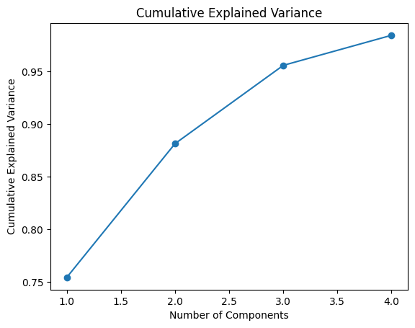

Fig 2.1 Four principal components explain 100% of the variance in the Bankex Data

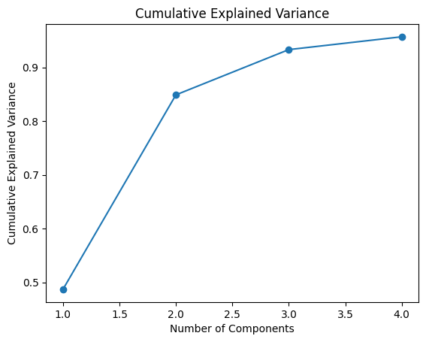

Fig 2.2 Four principal components explain 100% of the variance in the Auto-Index Data

Figures 2.1 and 2.2 depict the cumulative variance captured by all the principal components for Bankex and Auto Index data. In Fig 2.1 we find that the 1st principal component is able to capture upto 75% of the variance in the data whereas in Fig 2.2 the 1st principal component is able to explain upto 50% of variance in the data.

## 2.1 Hierarchical Clustering

Hierarchical Clustering is a popular method in data mining and machine learning used for grouping similar data points into clusters. It is a recursive approach that looks to partition the data into a hierarchy of nested clusters with each level representing. There are two approaches to hierarchical clustering, namely agglomerative clustering (bottom up) and divisive clustering (top down). In agglomerative clustering, each data point is considered a cluster and points are merged iteratively based on their similarity or proximity until all data points belong to a single cluster. This is the clustering approach that we have used in this research project. We perform agglomerative clustering using the complete linkage method on the reduced data. The steps of this method are as given below.

1. Initialization: Start with each data point as a singleton cluster. Each data point is considered a cluster of size one.
2. Calculate Distance matrix: Compute the pairwise distance between all pairs of clusters. We have used Euclidean distance for the same. In complete linkage, the distance between two clusters is defined as the maximum distance between any two points in the clusters.
3. Merge Closest Clusters: Find the pair of clusters with the smallest distance and merge the two clusters into one.
4. Update Distance Matrix: Recalculate the distance matrix to reflect the newly formed cluster and all other clusters based on the complete linkage criterion.
5. Repear steps 3 and 4 until all points are in a single cluster.

The results of Agglomerative clustering can be visualized using a Dendrogram. A dendrogram is a tree-like visualization that illustrates the order and manner in which clusters are merged, as well as the distance or similarity between clusters.

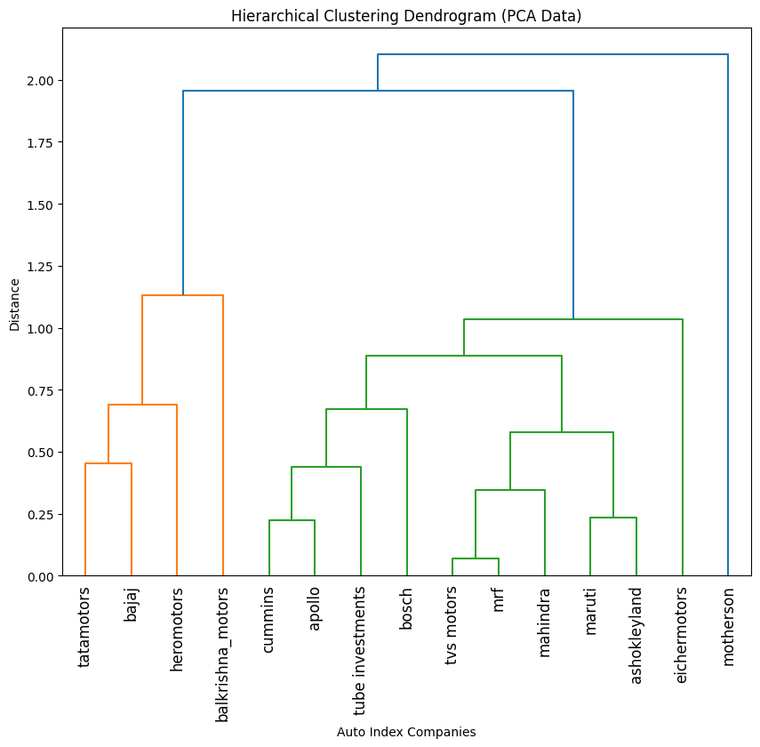

Fig 2.3 Dendrogram of Auto Index Data

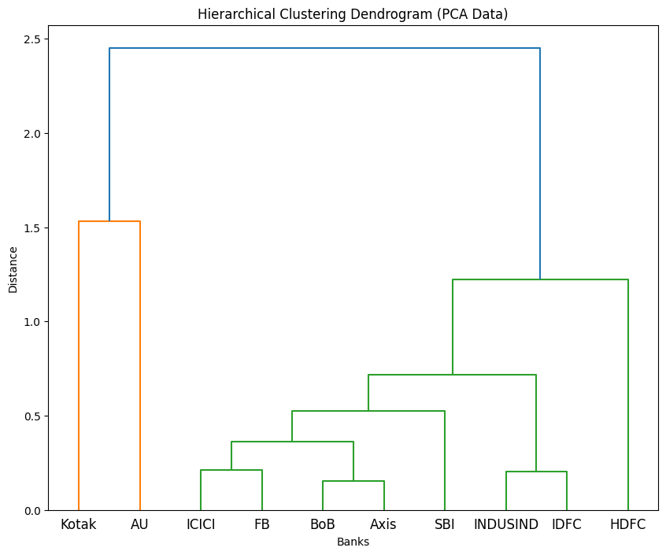

Fig 2.4 Dendrogram of Bankex Data

From Fig 2.3 we infer that TVS motors and MRF have the smallest distance between them and hence are a part of the 1st cluster that was identified. Also, the cluster containing Tata Motors, Bajaj, Hero Motors and Balkrishna Motors seem to have a significant level of dissimilarity from the cluster containing all the other companies.

From Fig 2.4 we infer that BoB and Axis have the smallest distance between them and hence are a part of the 1st cluster that was identified. The cluster containing Kotak and AU seems to have a significant level of dissimilarity from the cluster containing all the other banks.

For the Bankex data, we decided to have Axis and BoB in one cluster, ICICI and FB in another and similarly IDFC and INDUSIND. All the other banks are considered to be individual clusters. Thus from 10 individual banks, we now reduce it to 7 and aim to perform time series analysis for the 7 clusters.

For the Auto Index data, we have decided to have TVS and MRF in one cluster, Maruti and Ashok Leyland in another and similarly Cummins and Apollo. All the other companies are considered to be individual clusters. Thus from 15 individual companies we now reduce it to 12 and perform time series analysis for the 12 clusters.

## 2.2 Clustering Using Minimum Spanning Tree

Before delving into time series analysis, we tried an alternate approach to cluster data points by constructing a Minimum Spanning Tree from the reduced data. The minimum spanning tree is constructed and we place a threshold value and try to identify the clusters obtained.

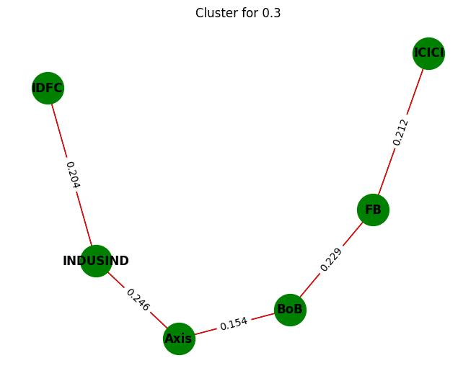

Fig 2.5 Clustering using MST for Bankex data

From the above Fig 2.5, we find that for a threshold of 0.3 Axis, BoB, FB, ICICI, INDUSIND, IDFC are identified as one cluster, with the edge weights denoting level of similarity.

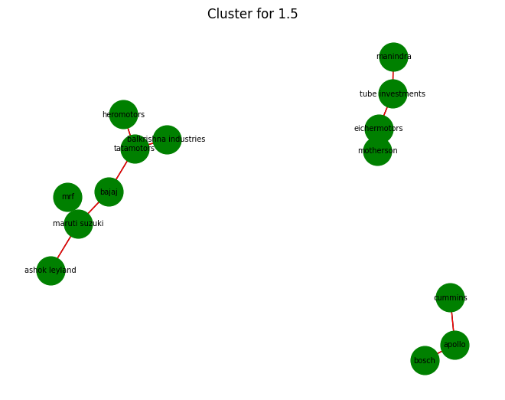

Fig 2.6 MST for Auto Index Data

From the above Figure, we are able to identify 3 different clusters for a threshold of 1.5

The drawback of the minimum spanning tree is that it only computes the distances once and returns clusters based on the threshold whereas a dendrogram uses a linkage matrix that is updated iteratively and thus is able to infer a larger number of clusters. Thus for the data we had, hierarchical clustering proved to be the better method as it provided richer insights.

# **Time Series Analysis of Bankex and Auto Index**

This section describes the most vital part of the project, which is the development of Time Series Models (ARMA/ARIMA/AR/MA) for the individual clusters. Before describing the methodology let us briefly look at what ARMA, ARIMA, AR and MA models mean.

## 3.1 Autoregressive Moving Average (ARMA)

* **Autoregressive component (AR)**
  + The ARMA model includes an autoregressive component, denoted by AR(p), where "p" represents the order of the autoregressive process. This component captures the linear relationship between the current value of the time series and its past values. Mathematically, an AR(p) process can be expressed as a linear combination of the previous "p" observations, where the coefficients represent the weights assigned to each lagged observation.
* **Moving Average component (MA)**
  + The ARMA model also includes a moving average component, denoted by MA(q), where "q" represents the order of the moving average process. This component captures the linear relationship between the current value of the time series and its past error terms (or residuals). Mathematically, an MA(q) process can be expressed as a linear combination of the previous "q" error terms, where the coefficients represent the weights assigned to each error term.

## 3.2 Autoregressive Integrated Moving Average (ARIMA)

* **Autoregressive Component**
  + Similar to the ARMA model, ARIMA includes an autoregressive component (AR(p)), which captures the linear relationship between the current value of the time series and its past values.
* **Moving Average Component**
  + ARIMA also includes a moving average component (MA(q)), which captures the linear relationship between the current value of the time series and its past error terms.
* **Integrated Component**
  + The "I" in ARIMA stands for integrated, indicating that ARIMA models incorporate differencing to achieve stationarity. Differencing involves computing the differences between consecutive observations to remove trends or seasonal patterns from the time series data. The order of differencing (denoted by "d") represents the number of times differencing is applied to achieve stationarity.

We look to understand the time series components like trend and seasonality of each company by plotting them. The results are as shown.

## 3.3 BSE Bankex

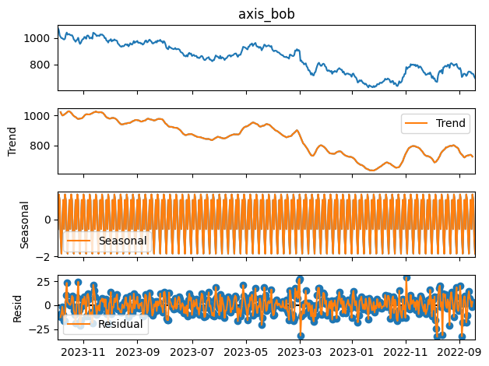

**Fig 3.1 Axis Bank- Bank of Baroda**

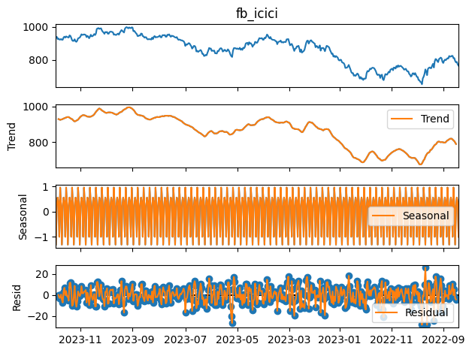

**Fig 3.2 Federal Bank-ICICI Bank**

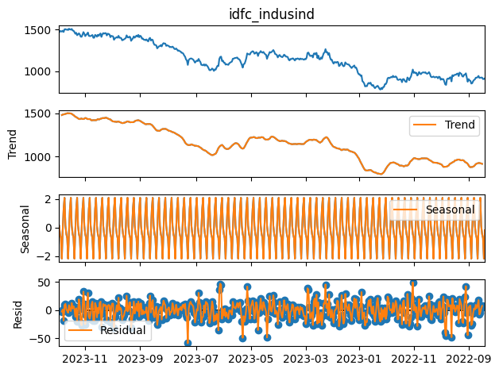

**Fig 3.3 IDFC Bank-INDUSIND Bank**

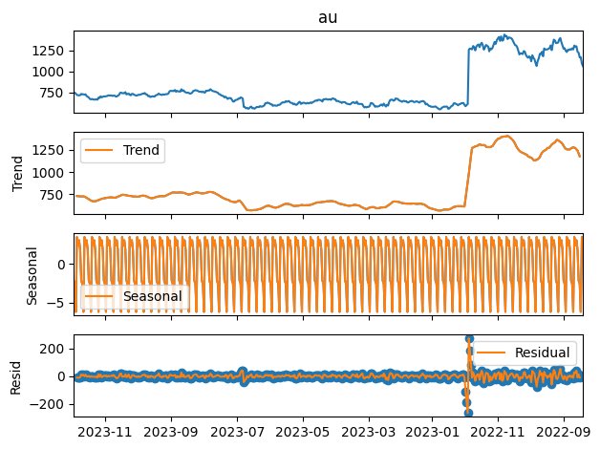

**Fig 3.4 AU Bank**

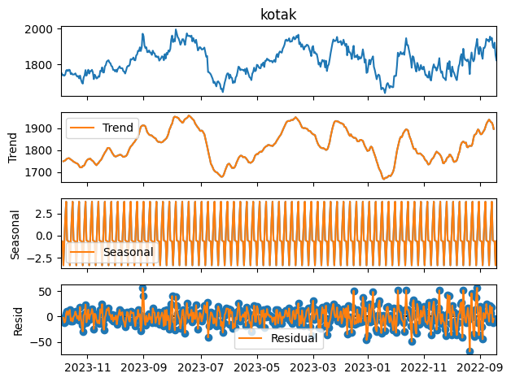

**Fig 3.5 Kotak Bank**

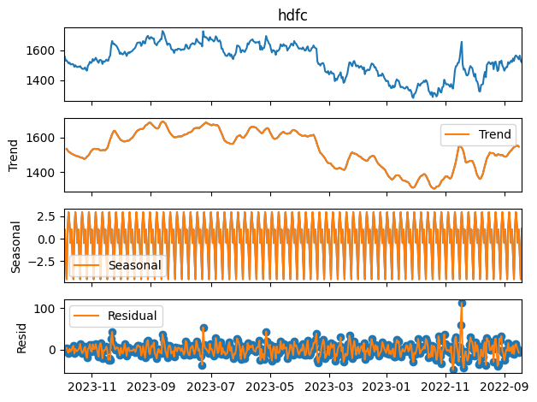

**Fig 3.6 HDFC Bank**

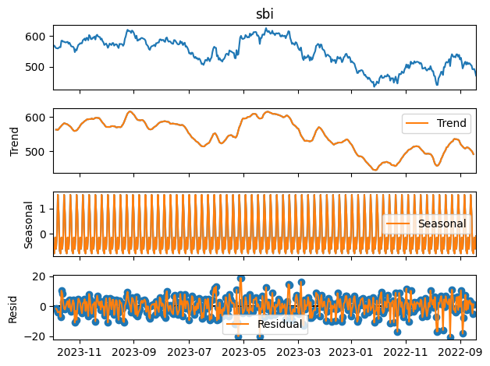

**Fig 3.6 SBI Bank**

From the above graphs, we can clearly infer that the data is not stationary, meaning its statistical properties like mean and variance keep changing. The variation in stock prices also display irregular behaviour. Thus, we cannot directly apply an ARMA model. ARMA model can only be applied if the data is stationary. So before finding the best model, we need to make the data stationary. This can be done by differencing the successive points. In this case, differencing was done once, and the data was found to be stationary. It is easier to analyse stationary data since the statistical properties do not change.

Now that we have made the data stationary, we now aim to find the best time series model for each bank. This is an iterative procedure and we try to find the order of AR (p) and MA within a range of (0,3). We use the AIC measure (Akaike Information Criterion), as a metric for choosing the best model. The model with the lowest AIC value is chosen to be the best fit for each cluster.

### 3.3.1 Results for Bankex

|  |  |
| --- | --- |
| Cluster | Model |
| Axis Bank and Bank of Baroda | ARIMA(2,0,2) |
| Federal Bank and ICICI Bank | ARIMA(0,0,1) |
| IDFC Bank and INDUSIND Bank | ARIMA(2,0,2) |
| AU Bank | ARIMA(1,0,0) |
| Kotak Bank | ARIMA(2,0,2) |
| HDFC Bank | ARIMA(2,0,2) |
| State Bank of India (SBI) | ARIMA(2,0,2) |

Once the time series models were obtained, the values for December 2023 were predicted and Mean Square Error was used to evaluate the models. The Actual vs Predicted value graphs for banks are shown.

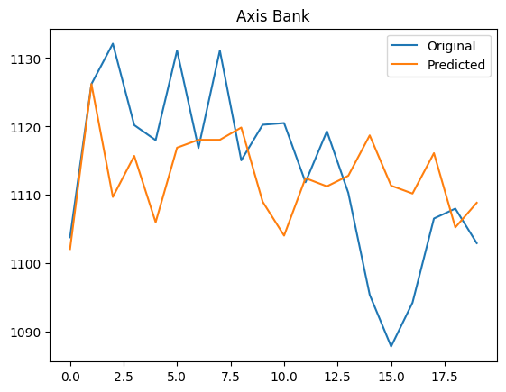

Fig 3.7

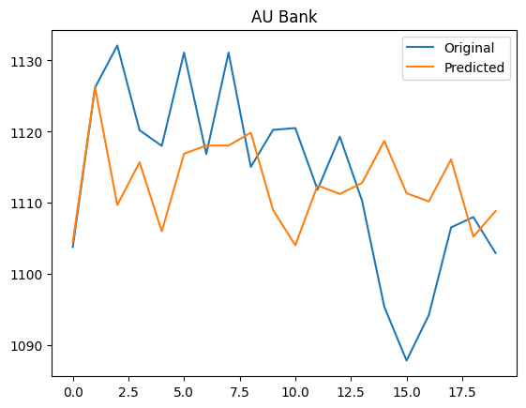

Fig 3.8

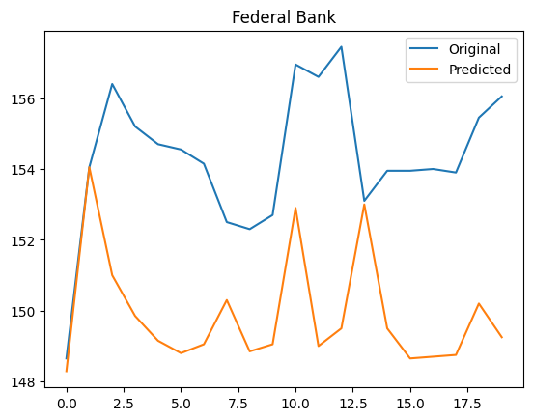

Fig 3.9

### 3.3.2 BSE Auto Index

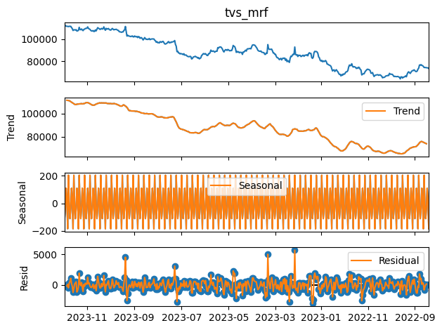

Fig 3.10

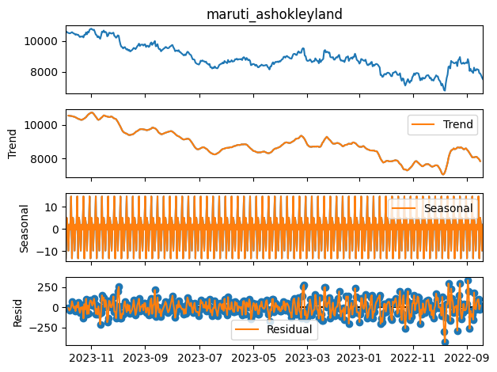

Fig 3.11

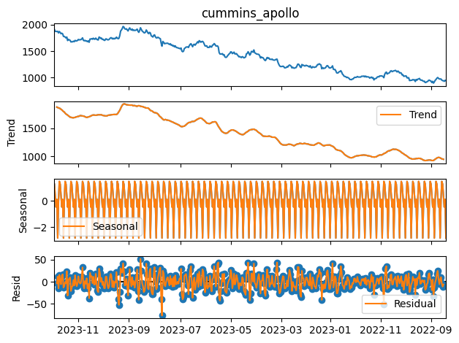

Fig 3.12

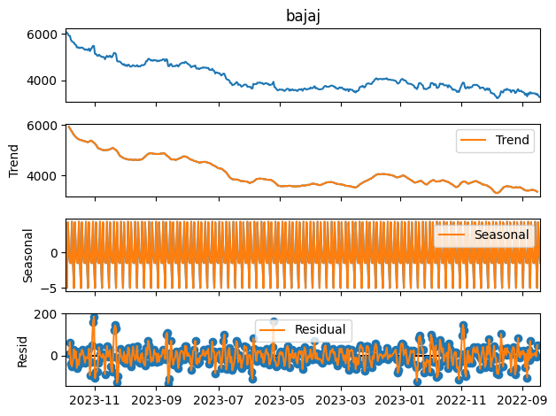

Fig 3.13

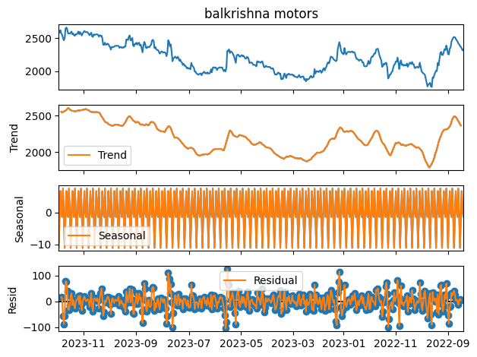

Fig 3.14

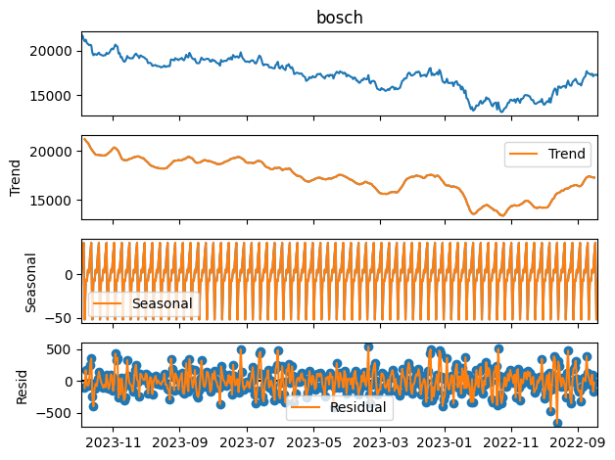

Fig 3.15

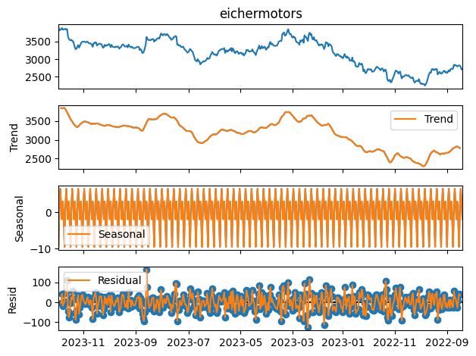

Fig 3.16

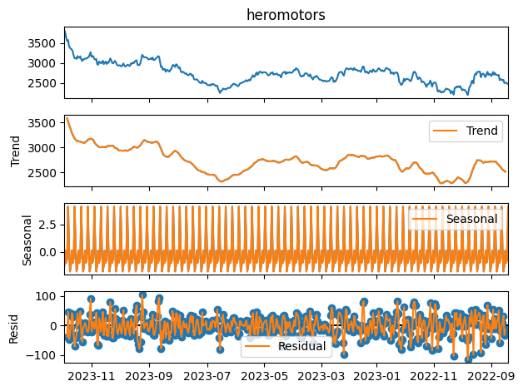

Fig 3.17

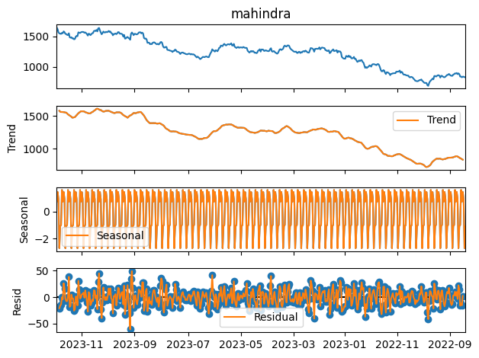

Fig 3.18

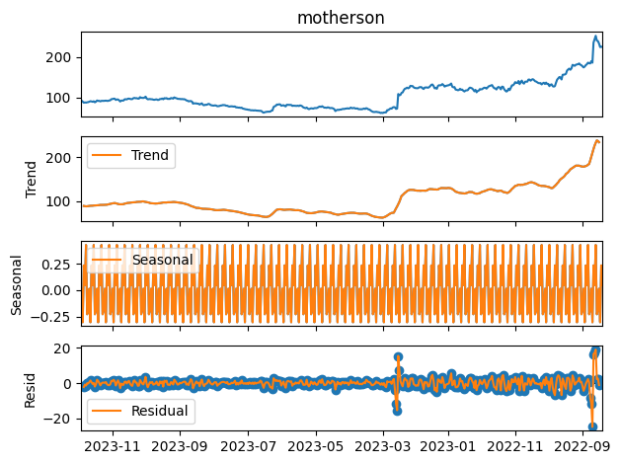

Fig 3.19

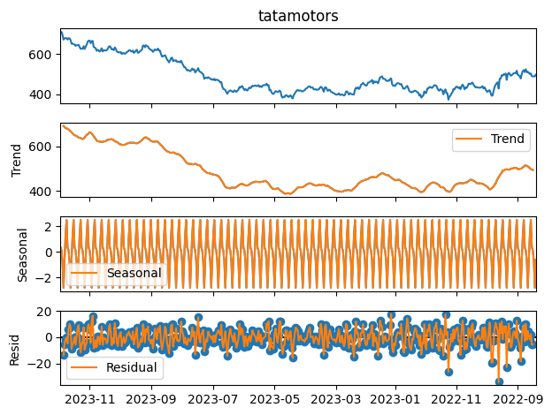

Fig 3.20

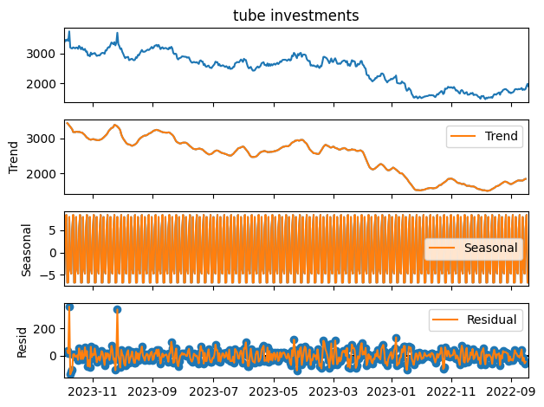

Fig 3.21

### 3.3.3 Results for BSE Auto Index

|  |  |
| --- | --- |
| Cluster | Model |
| TVS-MRF | ARIMA(2,0,2) |
| Maruti-Ashok Leyland | ARIMA(1,0,0) |
| Cummins-Apollo | ARIMA(2,0,2) |
| Bajaj | ARIMA(1,0,0) |
| Balkrishna Motors | ARIMA(0,0,2) |
| Bosch | ARIMA(0,0,1) |
| Eichermotors | ARIMA(0,0,1) |
| Heromotors | ARIMA(2,0,2) |
| Mahindra | ARIMA(0,0,1) |
| Motherson | ARIMA(1,0,0) |
| Tatamotors | ARIMA(0,0,1) |
| Tube Investments | ARIMA(1,0,0) |

Similar to the Bankex, the closing stock prices were predicted for December 2023 and mean square error was used to evaluate the performance.

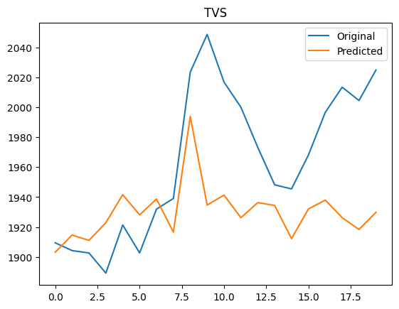

Fig 3.22 TVS

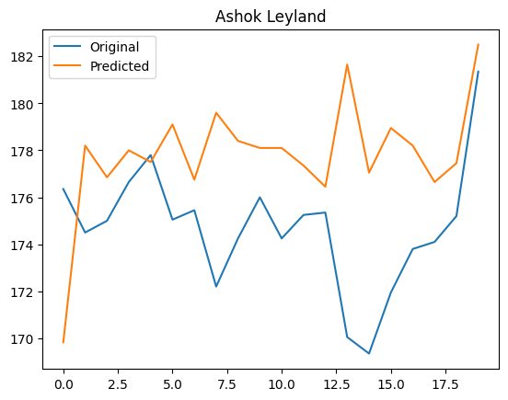

Fig 3.23 Ashok Leyland

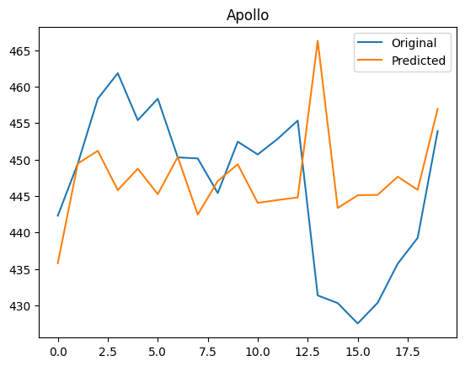

Fig 3.24 Apollo

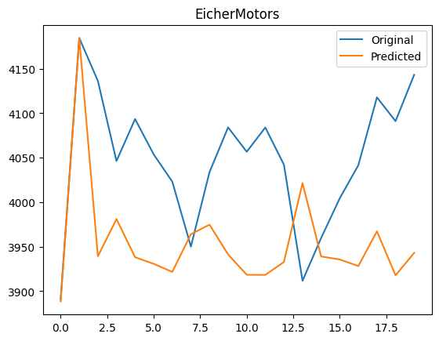

Fig 3.25 EicherMotors

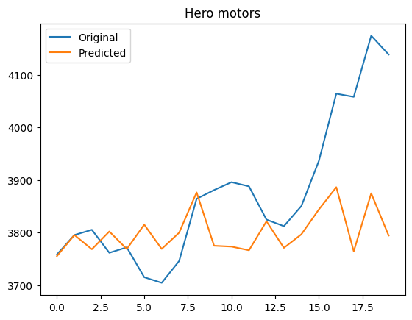

Fig 3.26 Hero Motors

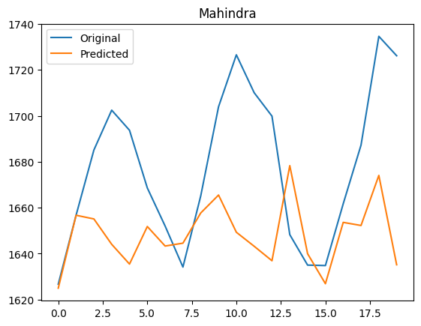

Fig 3.27 Mahindra

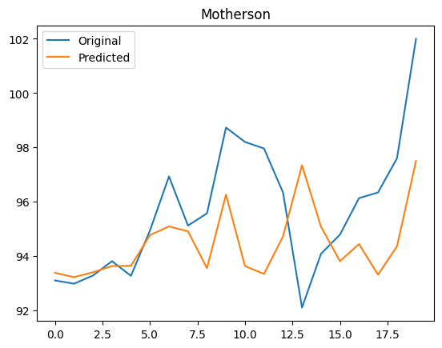

Fig 3.28 Motherson

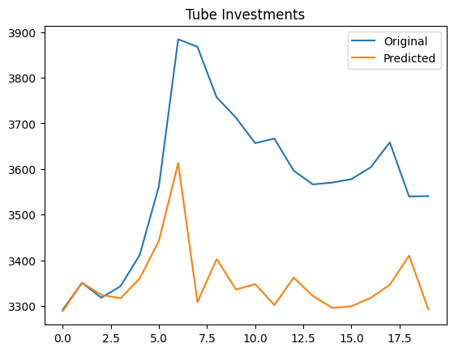

Fig 3.29 Tube Investments

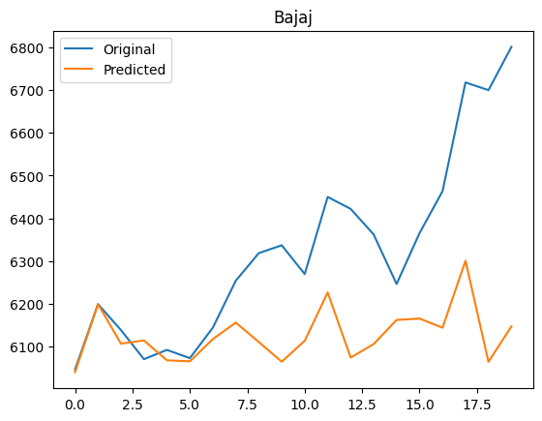

Fig 3.30 Bajaj

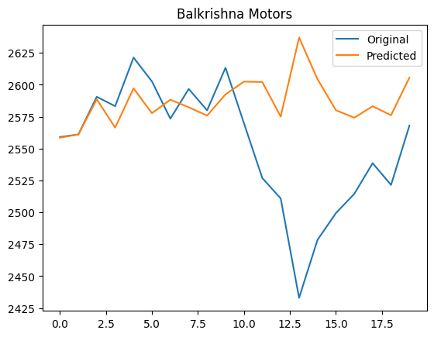

Fig 3.31 Balkrishna Motors

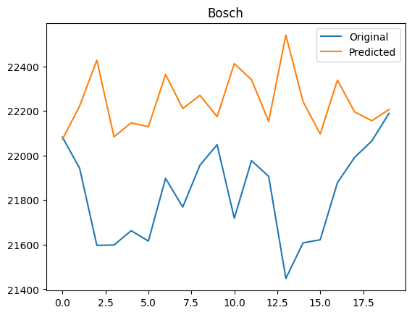

Fig 3.32 Bosch

# **Combing the Time Series Models**

Now that we have obtained individual models for banks and auto index companies, we tried to extend the idea by trying to combine the individual models into one single model. So, all the models for banks are combined into one single model. Similarly, all the individual auto-index models are combined into one single model. The idea is to combine each model by using different weights for each with the constraint that all the weights should add up to 1.

Essentially, we are trying to find convex combinations of all the companies. We generate random numbers for the weights and normalize them, in order to adhere to the constraint. We multiply the weights with the corresponding values predicted by each model and add them. We do this for the month of December 2023. We obtain all the predicted values and find the mean square error by comparing it with the actual values for December 2023. The weights for which the MSE is the least, is considered to be the optimal weights for each model. However, for each bank, the optimal weights obtained are not the same and differ. The results are as shown.

## 4.1 Results for BSE Bankex

|  |  |
| --- | --- |
| Cluster | Optimal Weights |
| Axis-BoB | [0.2900908185568677, 0.1524629561451581, 0.16409131743929273, 0.12183493565498126, 0.20030569843004845, 0.0712142737736518] |
| FB-ICICI | [0.0071210689715655836, 0.978916653618481, 0.0015543086689191403, 0.00835130339030742, 0.0004312569048826612, 0.003625408445844083] |
| Kotak | [0.020316246228239077, 0.00018691873677370853, 0.9732368889893044, 0.0001104447084499066, 0.0003186409448512167, 0.005830860392381636] |
| AU | [0.21754372427531643, 0.0013686949201799892, 0.020309733491459935, 0.3318849826022745, 0.2215067034353732, 0.20738616127539602] |
| HDFC | [0.02527495253781422, 0.012124815524673552, 0.1700736760180994, 0.09174695993993652, 0.6474999853155002, 0.05327961066397612] |
| SBI | [0.08265113648584528, 0.3138914650107552, 0.037191688180750214, 0.06779111737540507, 0.010028512925950287, 0.4884460800212939] |

## 4.2 Results for BSE Auto Index

|  |  |
| --- | --- |
| Cluster | Optimal Weights |
| TVS-MRF | [0.7696281026624708, 0.04501026450062281, 0.03428668599916671, 0.00227786772573437, 0.047679297434965504, 0.004872057381412266, 0.003986463789565384, 0.03108291048693746, 0.02199872114641309, 0.03199886500667489, 0.007178763866036623] |
| Maruti-Ashok Leyland | [4.277537231760183e-06, 0.9999534875623918, 1.0036425412286165e-05, 2.9748579803354468e-06, 2.97788195262637e-06, 3.776862751943092e-07, 5.588135722573045e-06, 8.274650968530693e-06, 2.494198172387867e-06, 5.507568310043062e-06, 4.00349558259615e-06] |
| Cummins-Apollo | [0.0019625253536085124, 0.0015903496699354108, 0.9750297840829868, 8.60333946447482e-05, 0.003833837031966539, 0.0015886253266311483, 0.000816780917533225, 0.0034376364993810634, 0.003050949209916545, 0.0046317862485598885, 0.003971692264836059] |
| Bajaj | [0.015796095474175053, 0.006142189162550027, 0.004511965541722955, 0.7774972451267883, 0.023826714562142706, 0.04379958664819511, 0.026389149812022863, 0.04411258617386931, 0.015390404640585127, 0.03877824971843759, 0.0037558131395110227] |
| Balkrishna Motors | [0.009958228750747483, 0.041439083937512305, 0.028643090569681843, 0.02867301694778767, 0.7432134707519004, 0.0024420686241396583, 0.036335781087989745, 0.00044537675675865844, 0.030787860980253084, 0.020103760193174888, 0.05795826140005418] |
| Bosch | [0.006344480246616851, 0.0006940586536170742, 0.004641655231982205, 0.0022321869508436514, 0.0030815665292795143, 0.975605280657629, 0.002861426515508218, 0.002032175236851427, 0.0009247694428035201, 0.0011813157892732358, 0.00040108474559530176] |
| Eicher | [0.03185588425659057, 0.0026940486476589383, 0.04466431538322062, 0.03507043495559993, 0.030710999302673302, 0.014655994433327463, 0.8087227263219208, 0.0011972152192940182, 0.022662781981189865, 0.004239194482475409, 0.00352640501604908] |
| Hero Motors | [0.017255178454562228, 0.030411241098109044, 0.00769201407280477, 0.04894787561600281, 0.05295514079611845, 0.009752374474660715, 0.05676521352301903, 0.7424733637392292, 0.005018535794838945, 0.015094013913522015, 0.013635048517132846] |
| Mahindra | [0.0033660453014245305, 0.0008915124817573053, 0.0012961618307881, 0.0034748410701140268, 0.0005092303223672294, 0.00030489438232023797, 0.004703381514704245, 0.0024453745413642617, 0.9778019406856379, 0.005114872237459966, 9.174563206220232e-05] |
| Motherson | [4.1533549359068385e-05, 0.0016805145687959736, 0.0011910357543782675, 0.0006938673021915845, 0.0004551690651349763, 6.11853293799498e-05, 0.0027393378474235173, 0.001107033218827176, 0.003960407007575141, 0.9868238893498396, 0.0012460270070946853] |
| Tube Investments | [0.00296454579869432, 0.010013966592252982, 0.006922958175361282, 0.006172189867765016, 0.00708113812902151, 0.0038534575011619186, 4.663617559096405e-06, 0.004062130949084663, 0.005991283121258516, 0.002939297854207022, 0.9499943683936336] |